# BUG REPORT

*Newly found Bugs will updated *

## BUG 1

Title: Unwanted Redirection after wrong password is entered during Admin login

Attachment: 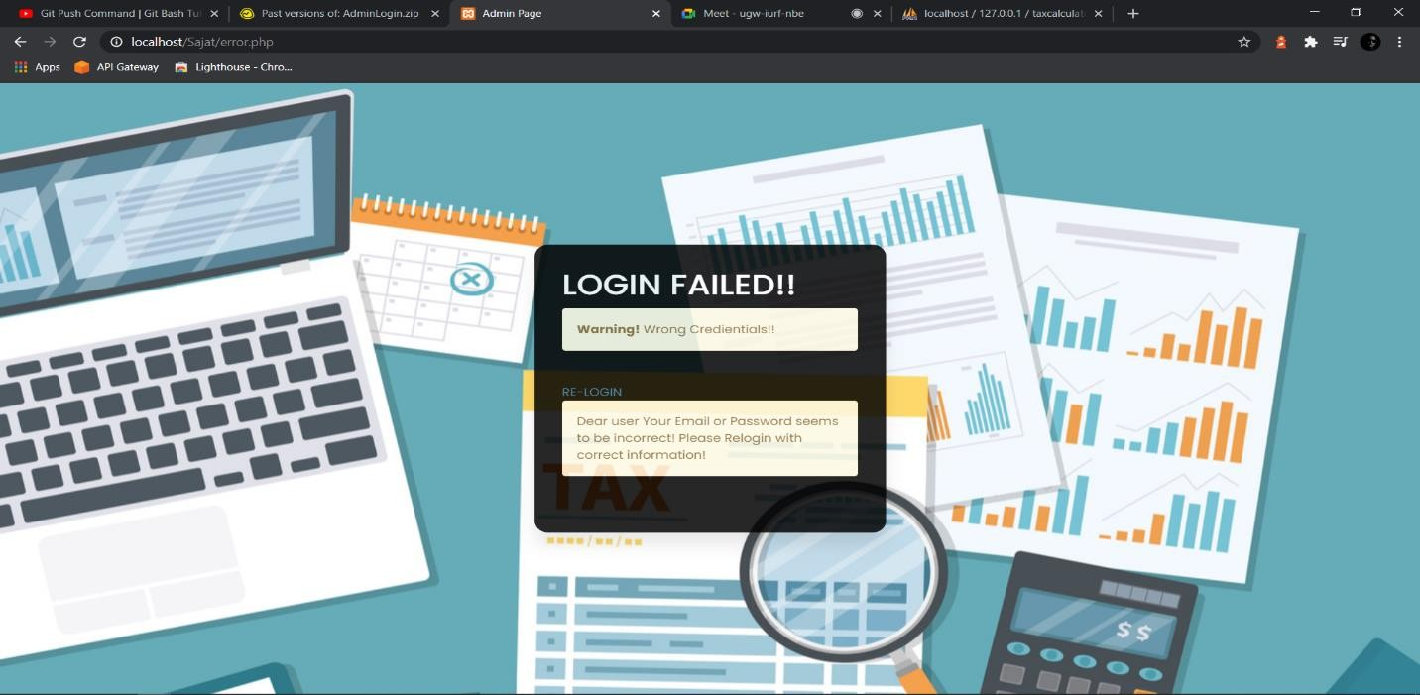

Steps to reproduce:

1. Sign Up with a verified email address
2. Go to the login form and enter your email
3. Enter a wrong password

Environment: Microsoft Edge Version 90.0.818.56

## BUG 2

Title: Admins should not be allowed to try with an incorrect password as much as they want

Attachment: 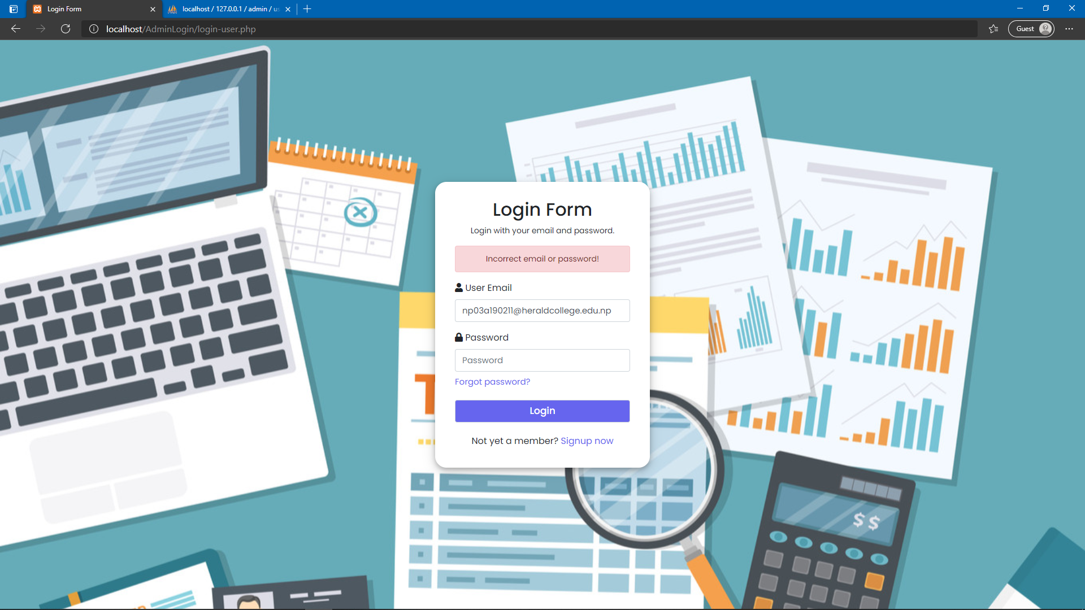

Steps to reproduce:

1. Sign Up with a verified email address
2. Go to the login form and enter your email
3. Enter wrong password more than three times

Environment: Microsoft Edge Version 90.0.818.56

## BUG 3

Title: Forgot Password Should not be allowed for unverified users

Attachment: 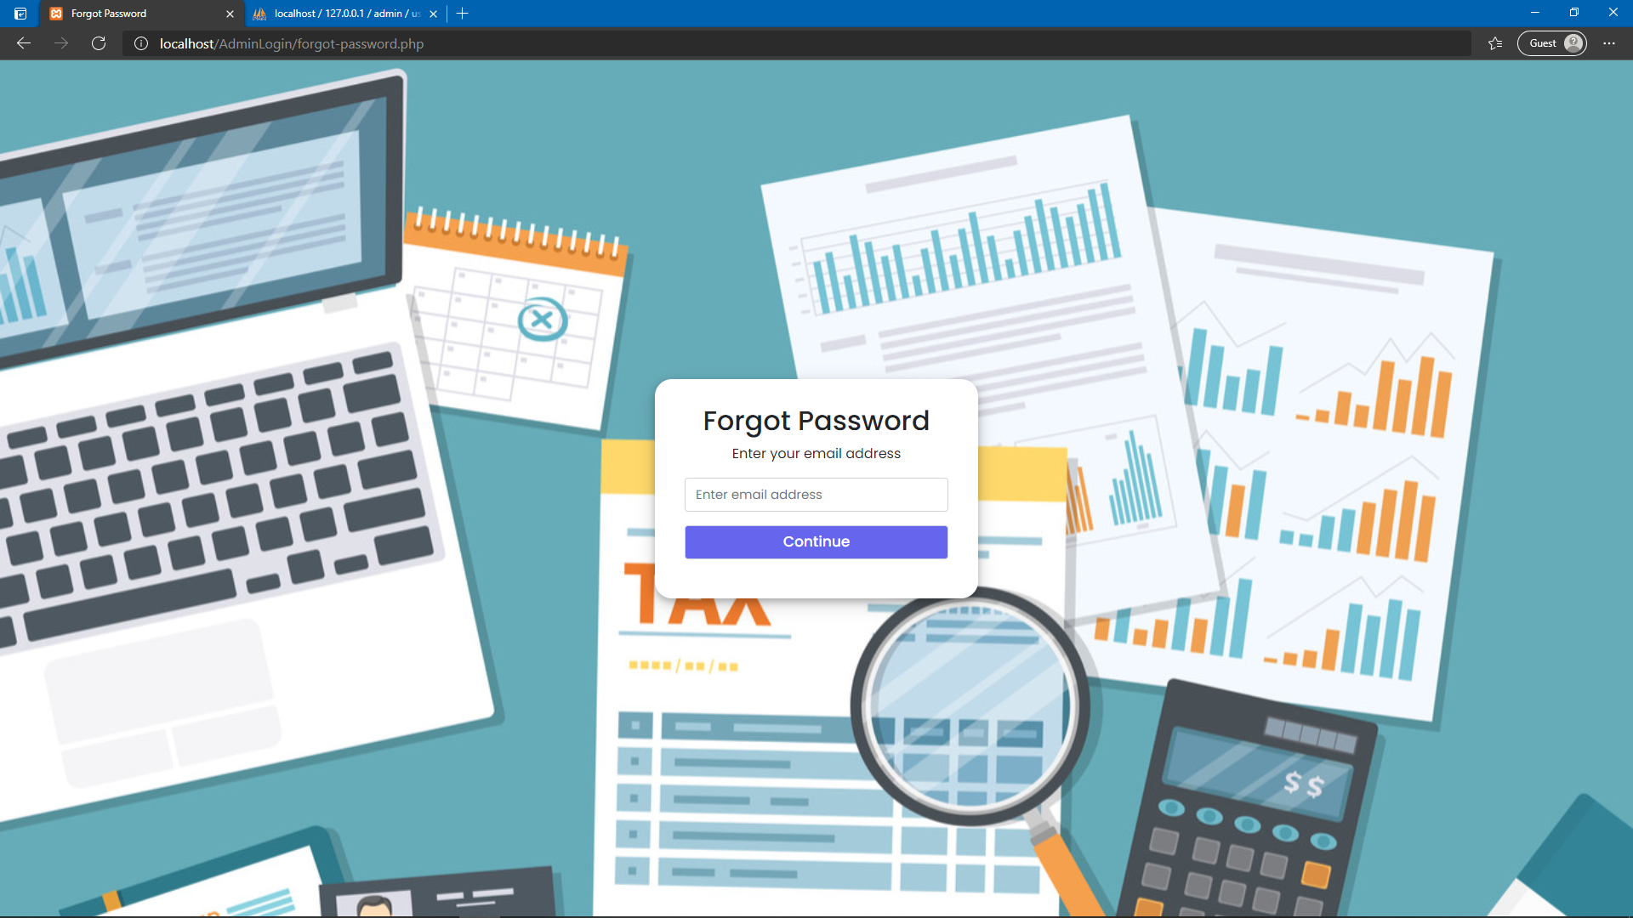

Steps to reproduce:

1. Sign Up for an account but don’t enter the OTP code
2. Go to the Login Screen
3. Go to the forgot password option
4. Enter the unverified email

Environment: Microsoft Edge Version 90.0.818.56

## BUG 4

Title: The spelling of password in the forgot password screen

Attachment: 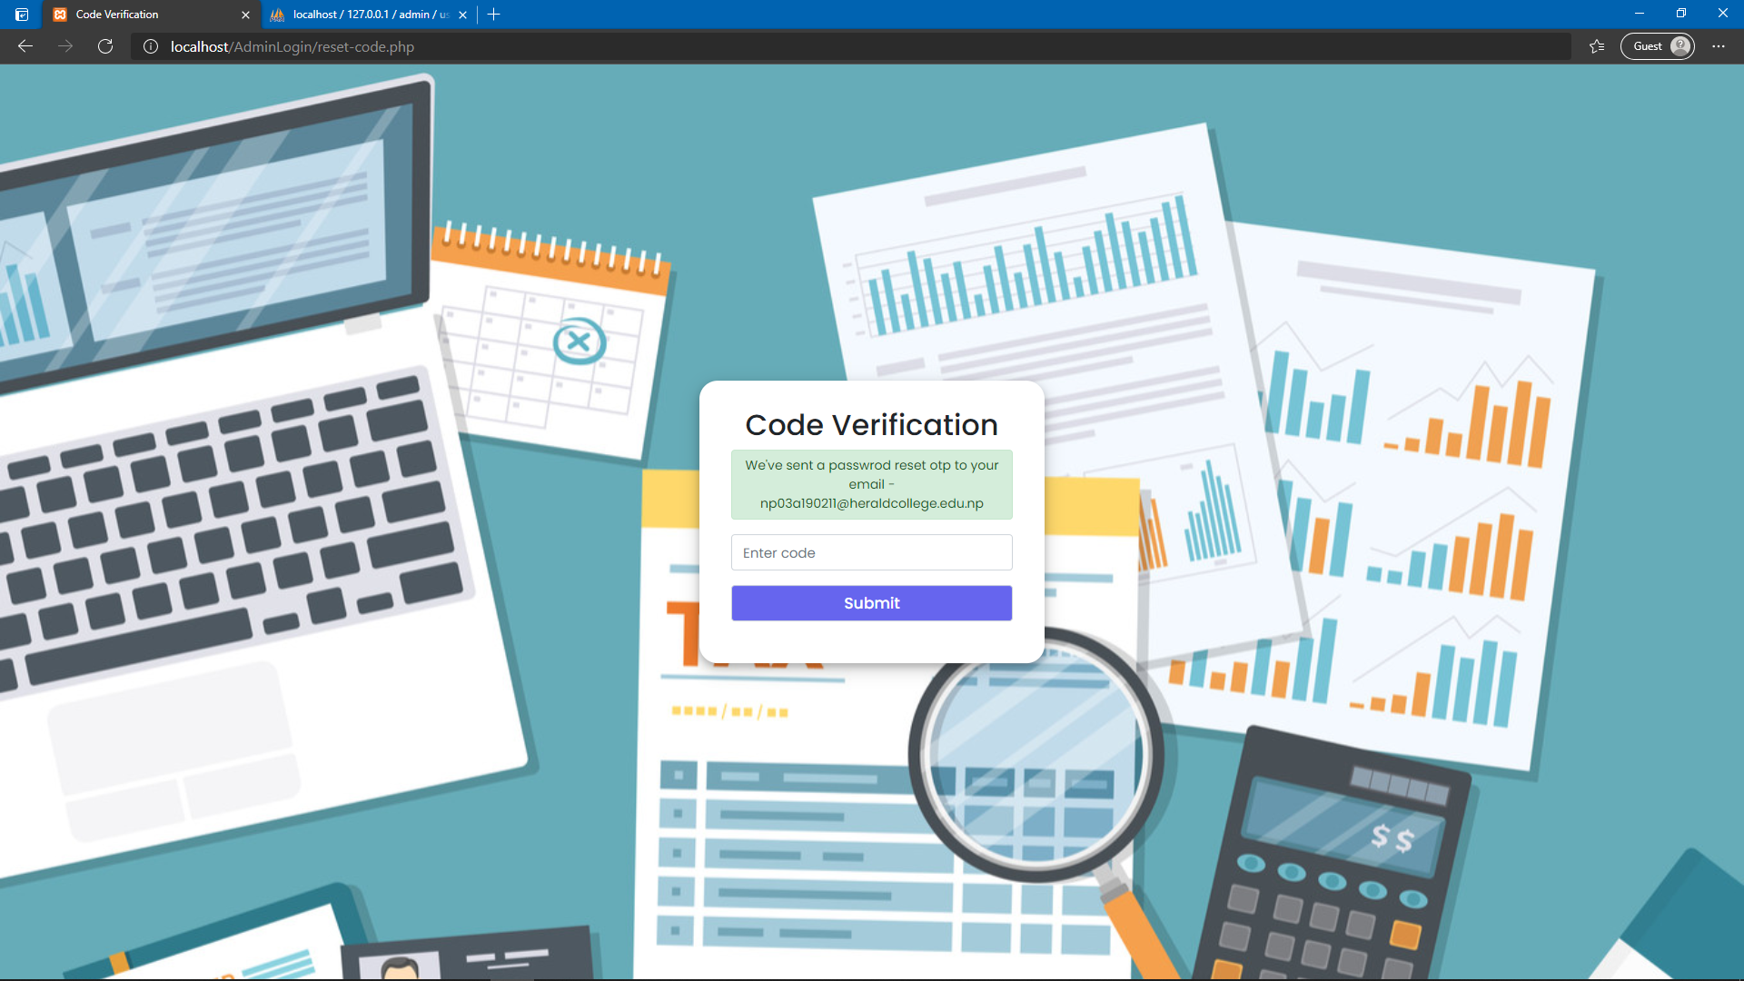

Steps to Reproduce:

1. Sign Up for an account
2. Go to login screen
3. Enter the forgot password option
4. Enter the email address

Environment: Microsoft Edge Version 90.0.818.56

## BUG 5

Title: Passwords should be minimum of 8 characters

Attachment:

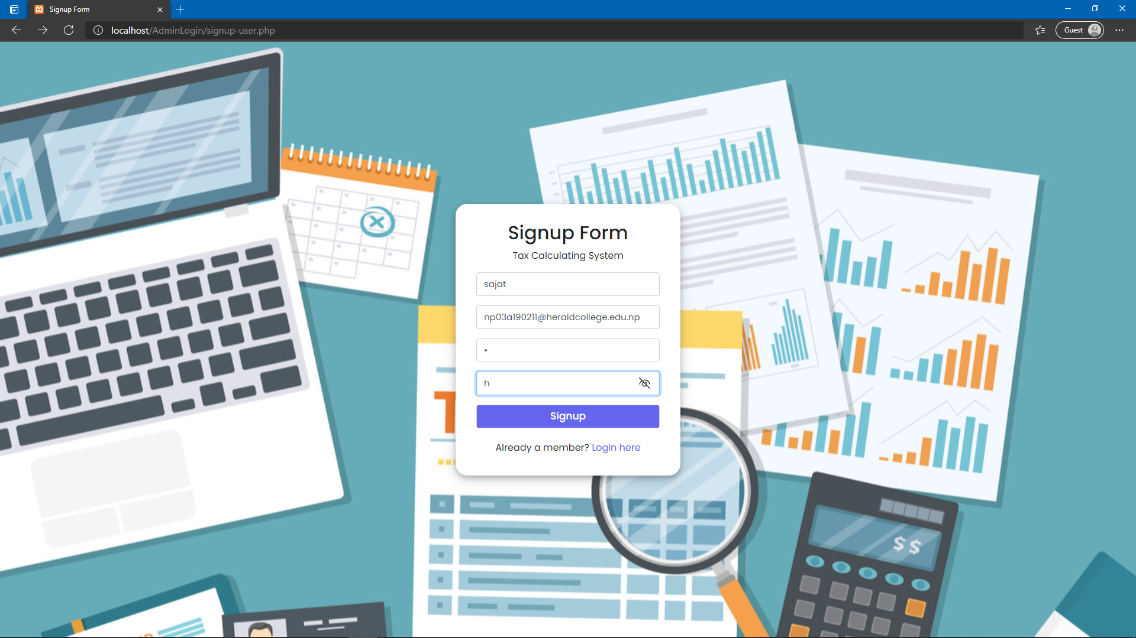

Steps to Reproduce:

1. Go to the Sign-Up screen
2. Enter all the details but add only one-character password

Environment: Microsoft Edge Version 90.0.818.56

## BUG 6

Title: Using unadded Gmail to sign up

Attachment:

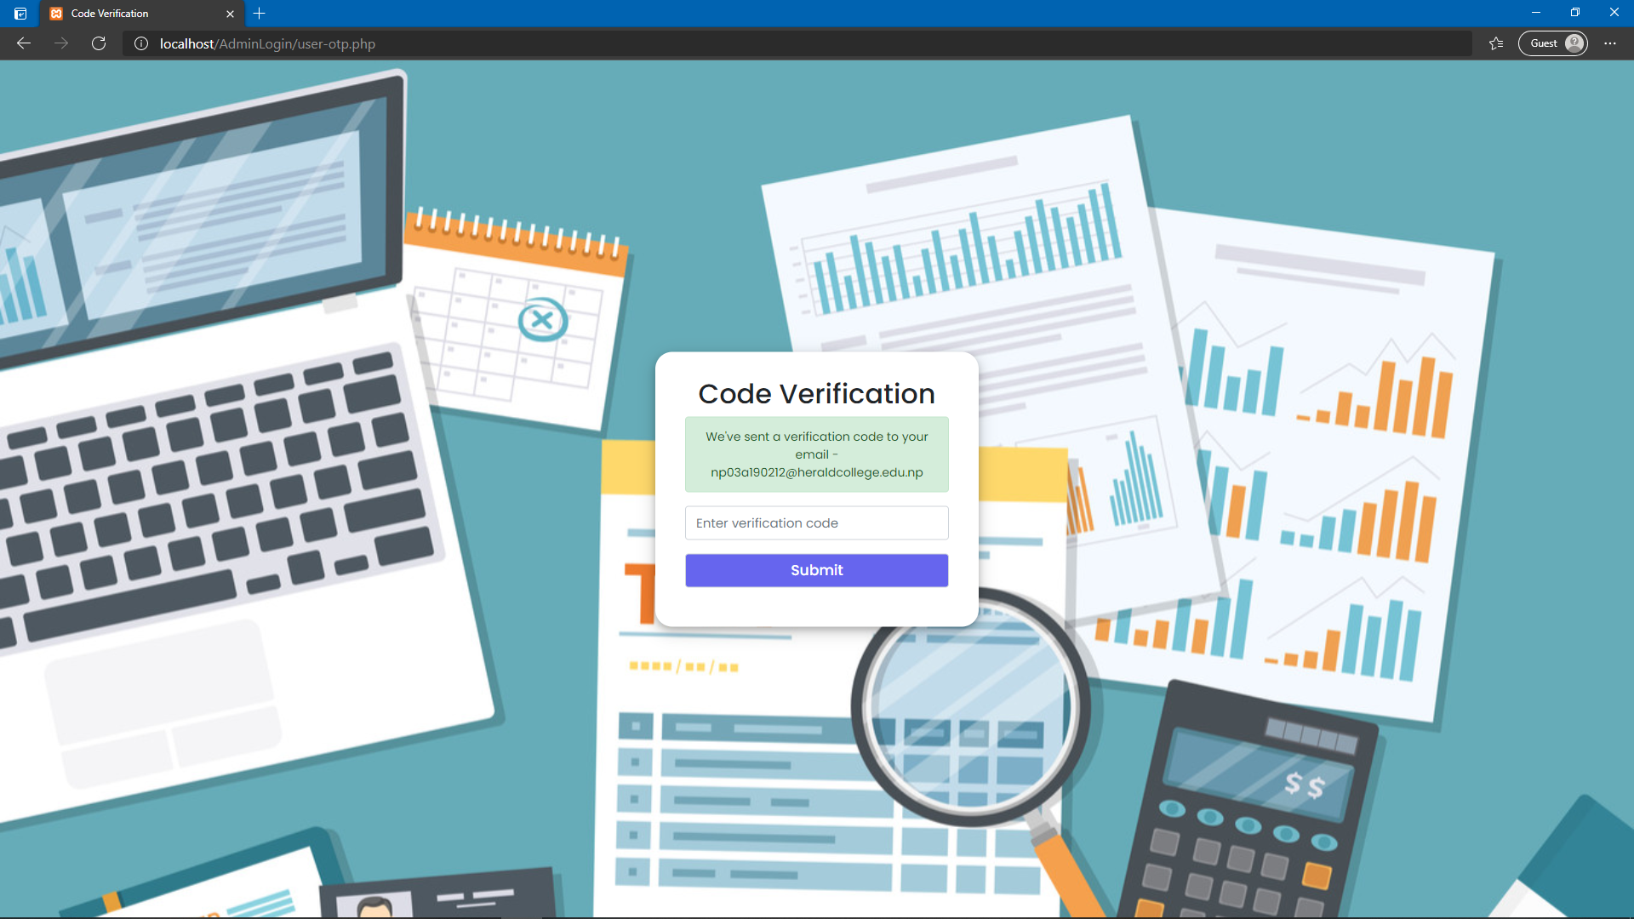

Steps to reproduce:

1. Go to the sign-up screen
2. Enter all the details but add a Gmail not added by other admins in the list of verified emails.
3. The new admin is let to sign up

Environment: Microsoft Edge Version 90.0.818.56